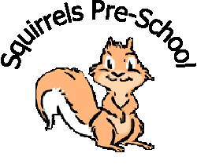 www.squirrelspreschoolrugby.co.uk
Squirrels Pre-School Rugby Ltd
^{c}/_{o} Paddox Primary School
Fareham Avenue
Rugby
Warwickshire
CV22 5HS
Preschool.s@welearn365.com
01788 576167
A Unique Child | Positive Relationships | Enabling Environments | Learning and Development
Keep children safe | Setting clear boundaries | Value all people | Physical

No Smoking Policy

Statement of intent

It is our intention to make Squirrels a safe and healthy place for children, families and staff.

Aim

We aim to provide a healthy and safe environment whilst promoting the welfare of children.

Method

- We believe strongly in setting a good example to the children in our care and protecting their health and safety; therefore we adhere to the No Smoking Policy at all times.

- The no smoking policy applies to staff, directors, parents and visitors to Squirrels, whilst in the setting and in the Pre-school outside area and Paddox School grounds. This includes the smoking of e-cigarettes/vapes.

- Any person found smoking will be asked politely to leave.

- No Smoking signs are displayed at the entrance and inside Squirrels Pre-School.

This policy was adopted by the directors of Squirrels Pre-School Rugby Ltd

on…………26/01/2024………………………………………

Signed on behalf of the Board of Directors……………………………………………………………………….

Signed by Manager………………………………………………………………

Date of policy review ……………January 2025…………………..
Signed copy held in setting

Page 1

